
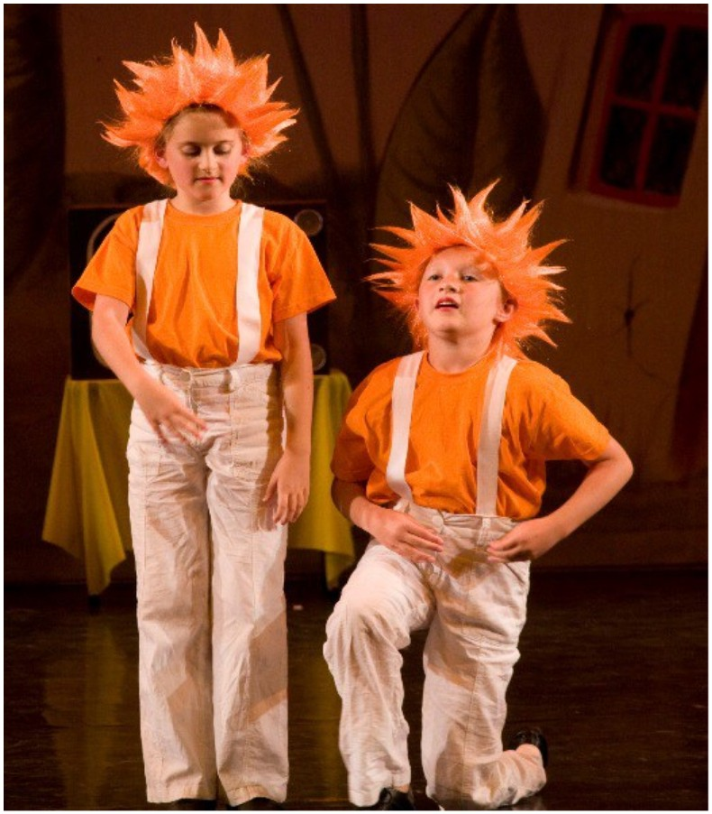
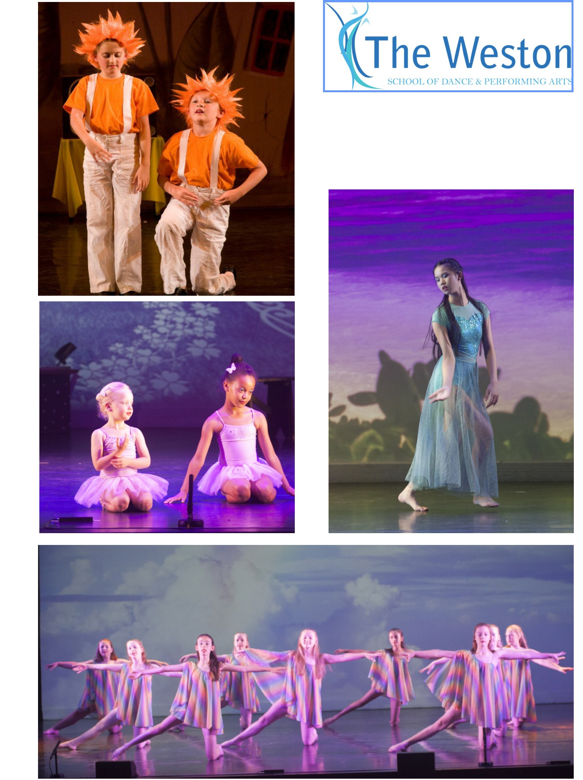
01245 287638
Junior

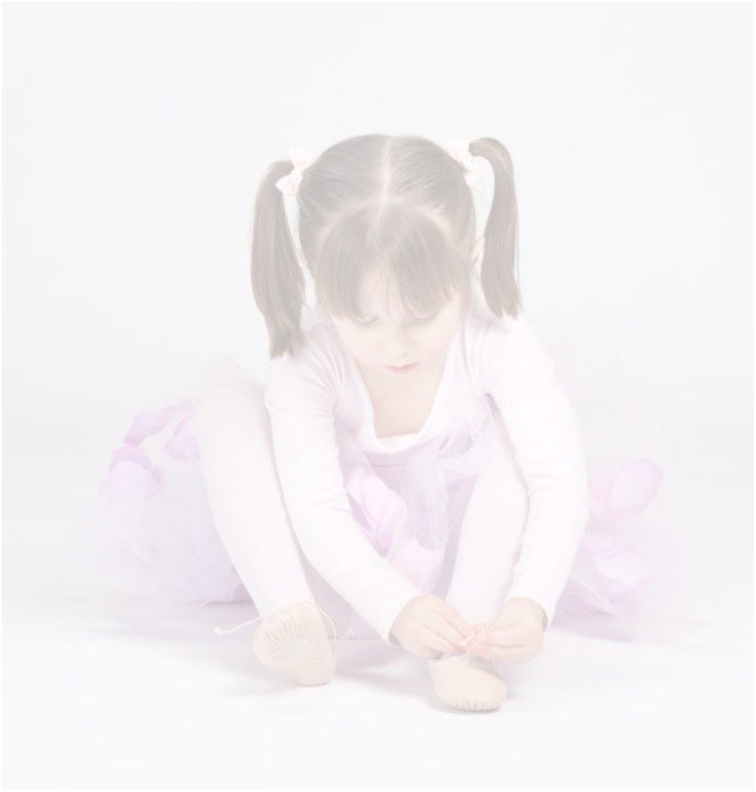
With over 60 classes per week we list here classes for younger children in ballet, modern
theatre and tap dance, together with musical theatre, contemporary dance and commercial
dance/jazz classes. For the full ꢀmetable please refer to our website or contact the School
Oﬃce - see details on page 4.
VENUES
CYGAMS HQ, Meteor Way, oﬀ Waterhouse Lane, Chelmsford, CM1 2RL
Farthing Hall, rear of Christchurch, 164 New London Road, Chelmsford, CM2 0AW
Widford Village Hall, Widford Road (oﬀ Chandler’s roundabout), Chelmsford, CM2 8SY
Beaulieu Community Centre, Beaulieu Square, Centenary Way, CM1 6AU
Chelmer Village Hall, Village Square, Chelmer Village, CM2 6RF
Springﬁeld Parish Centre, St Augusꢀne’s Way, CM1 6GX Great Dunmow Primary School, Woodlands Park Drive, CM6 1ZR
CLASSICAL BALLET
PLEASE NOTE: all ages are for guidance only
*NEW CLASSES require a minimum number of students to register to take place*
BALLET WITH YOUR BEAR (3 to 4¾ years) A fun, foundaꢀon class for pre-schoolers
Monday AF1/KO 3.30 pm - 4.00 pm Beaulieu Community Centre *NEW CLASS*
Thursday DG1/KO 4.00 pm - 4.30 pm Chelmer Village Hall *NEW CLASS*
Friday EH1/KO 4.00 pm - 4.30 pm Springﬁeld Parish Centre *NEW CLASS*
Saturday FS1/RF 9.15 am - 9.45 am Widford Village Hall
Saturday FP1/KO 9.15 am - 9.45 am Great Dunmow Primary School
PRIMARY (age 4¾ to 6 years - This is to ensure that they are physically developed
suﬃciently to safely meet the demands of the syllabus)
Thursday DG2/KO 4.30 pm - 5.15pm Chelmer Village Hall *NEW CLASS*
Friday EL2/JL 4.30 pm - 5.15 pm Springﬁeld Parish Centre
Saturday FS2/RF 9.45 am - 10.30 am Widford Village Hall
STANDARD 1 (age 6 & 7 years)
Monday AF2/KO 4.00 pm - 4.45 pm Beaulieu Community Centre
Thursday DG3/KO 5.15 pm - 6.00 pm Chelmer Village Hall *NEW CLASS*
Friday EH2/KO 4.30 pm - 5.15 pm Springﬁeld Parish Centre
Saturday FP2/KO 9.45 am - 10.30 am Great Dunmow Primary School
Saturday FS6/RF 12.00 pm - 12.45 pm Widford Village Hall
STANDARD 2 (age 8 & 9 years)
Friday EH3/KO 5.15 pm - 6.15 pm Springﬁeld Parish Centre
Saturday FJ1/ES 9.30 am - 10.30 am Great Dunmow Primary School
Saturday FS8/RF 1.30 pm - 2.30 pm Widford Village Hall
GRADE 2 (age 9 & 10 years)
Monday AF3/KO 4.45 pm - 5.45 pm Beaulieu Community Centre
Thursday DA2/RF 5.00 pm - 6.00 pm CYGAMS HQ Friday EA2/ES 4.30 pm - 5.30 pm CYGAMS HQ
Friday EH4/KO 6.15 pm - 7.15 pm Springﬁeld Parish Centre


MODERN THEATRE DANCE
MODERN MOVERS (age 4½ to 6 years) - providing an introducꢀon to both Modern & Tap
Saturday FS3/RF 10.30 am - 11.00 am Widford Village Hall
GRADE 1 (age 6 & 7 years)
Saturday FS7/RF 12.45 pm - 1.30 pm Widford Village Hall
GRADE 2 (age 7 & 8 years)
Saturday FC1/JL 9.30 am - 10.30 am Farthing Hall
TA P DANCE
GRADE 1 (age 6 & 7 years)
Saturday FS5/RF 11.00 am - 11.45 am Widford Village Hall
GRADE 2 (age 7 & 8 years)
Saturday FC2/JL 10.30 am - 11.30 am Farthing Hall
MUSICAL THEATRE
JUNIOR (age 7 to 12 years)
Saturday FP4/KO 11.15 am - 12.00 Pm Great Dunmow Primary School
COMMERCIAL JAZZ
JUNIOR (age 7 to 12 years)
Saturday FP3/KO 10.30 am - 11.15 am Great Dunmow Primary School
GENERAL (age 8 to 14 years)
Friday EL3/JL 5.00 pm - 6.00 pm Springﬁeld Parish Centre
CONTEMPORARY DANCE
GENERAL (age from 11 years)
Monday AF4/KO 5.45 pm - 6.45 pm Beaulieu Community Centre

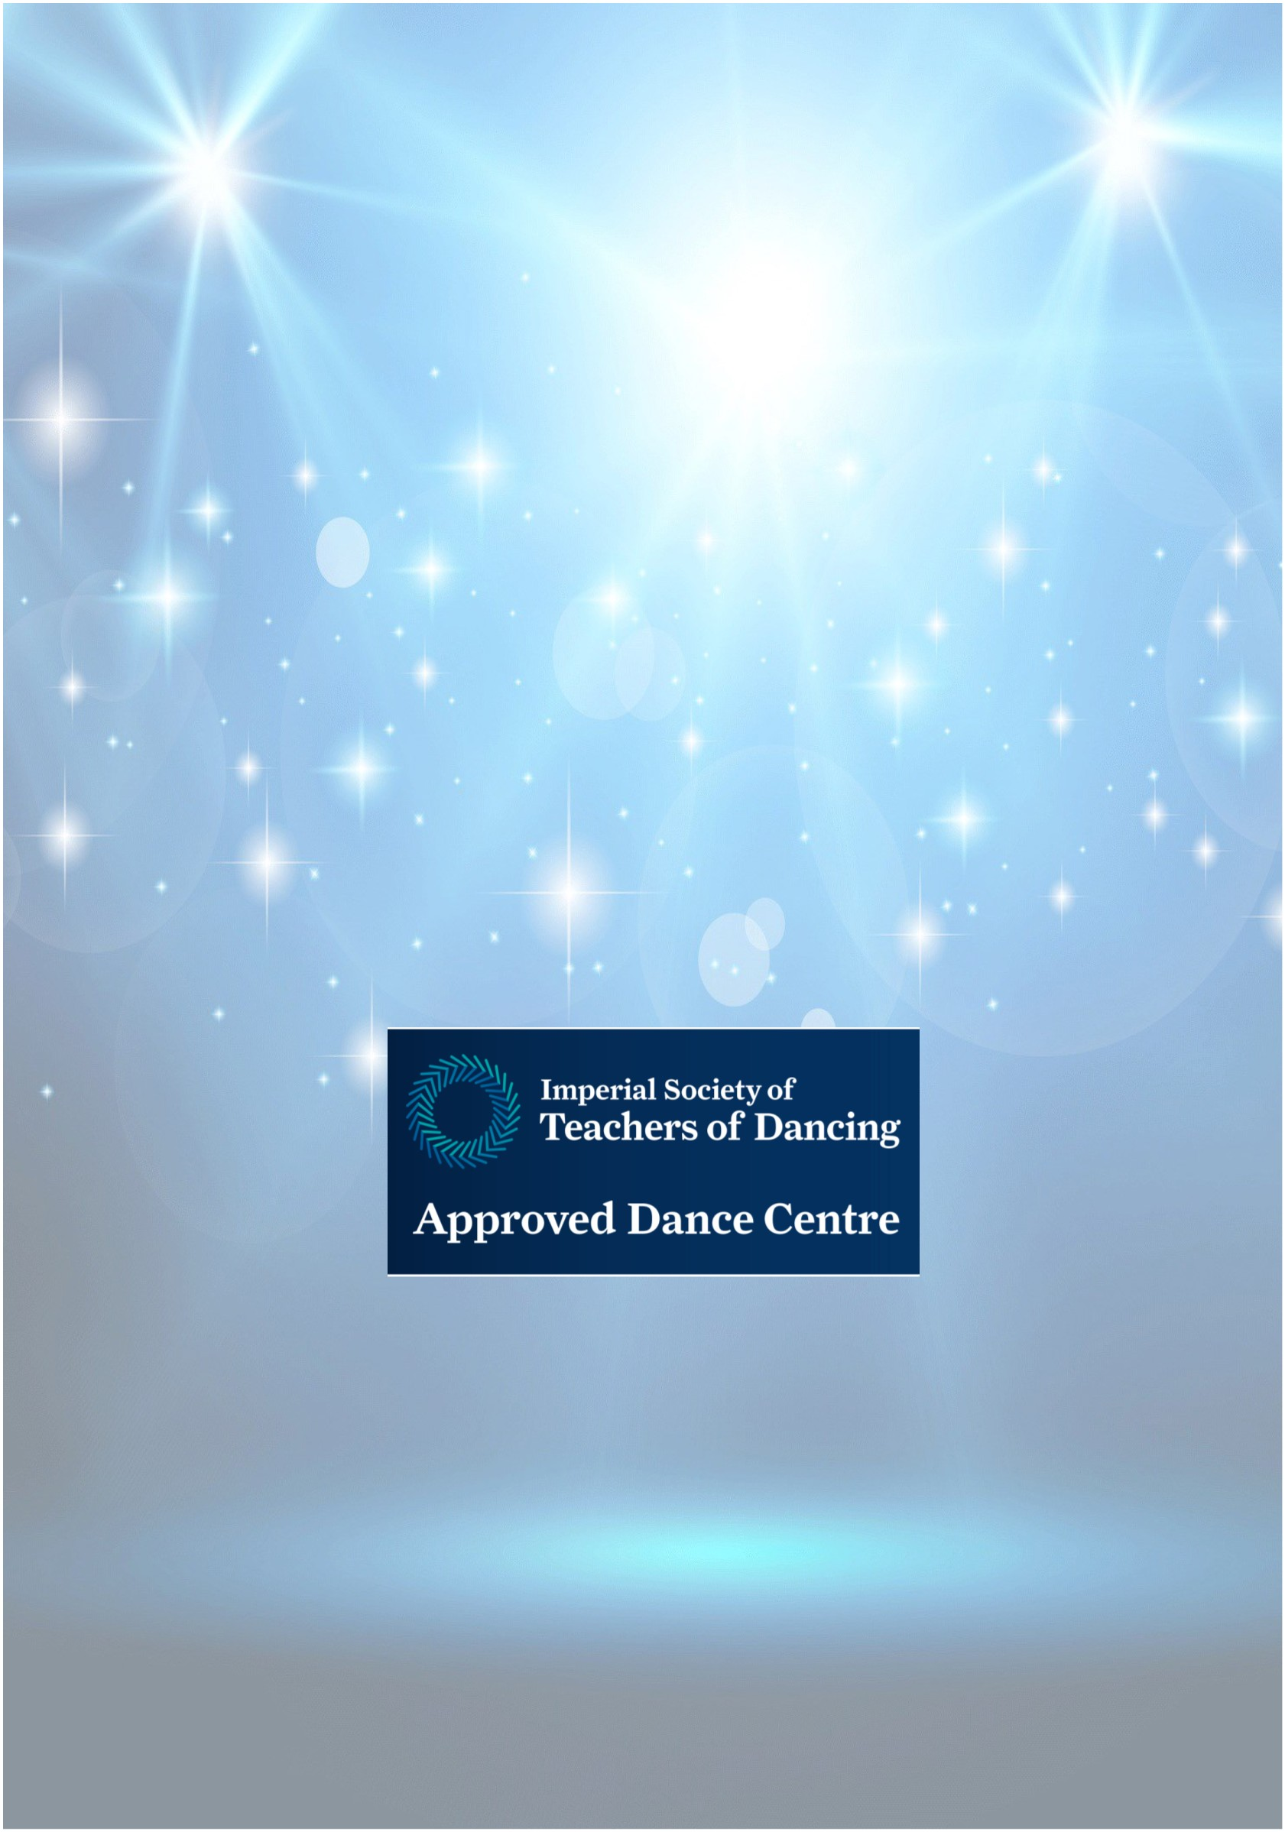
The Weston School of Dance, established in 1939, is recognised as one of the foremost
dance and theatre arts training establishments in Essex. We aim to provide the best
possible training to children, students and adults, in a safe and nurturing environment.
We want everyone to have fun and encourage all our students to achieve as well as they
possibly can, within their own physical and cogniꢀve ability. Examinaꢀons are not
compulsory but are oﬀered, through the ISTD Dance Examinaꢀons Board, to those
training in Ballet, Modern Theatre and Ta p dance.
Our team of experienced teachers, many of whom have performed professionally, are
passionate and enthusiasꢀc about what they do. We hope you will join us soon.
You will ﬁnd a wealth of addiꢀonal informaꢀon on our website:
www.theweston.dance or www.theweston.co.uk
Alternaꢀvely, you are welcome to telephone the School Oﬃce:
01245 287638
(weekdays during term-ꢀme, between 10.00 am and 1.00 pm & 24-hour voicemail)
or email:
oﬃce@theweston.dance or oﬃce@theweston.co.uk
For details of Senior, Vocaꢀonal and Professional Level classes,
plus classes for Adults,
please visit our website or contact the School Oﬃce
WHAT TO DO NOW
Once you have decided on the class or classes for which you wish to enrol
please complete the enrolment form and return this to the School Oﬃce. Your
enrolment will be acknowledged.
Conﬁrmaꢀon will be sent once a place becomes available. You, or your child,
will then be welcome to aꢁend a free trial lesson before making a
commitment.
© Weston School of Dance & Performing Arts 2026 E&OE

