
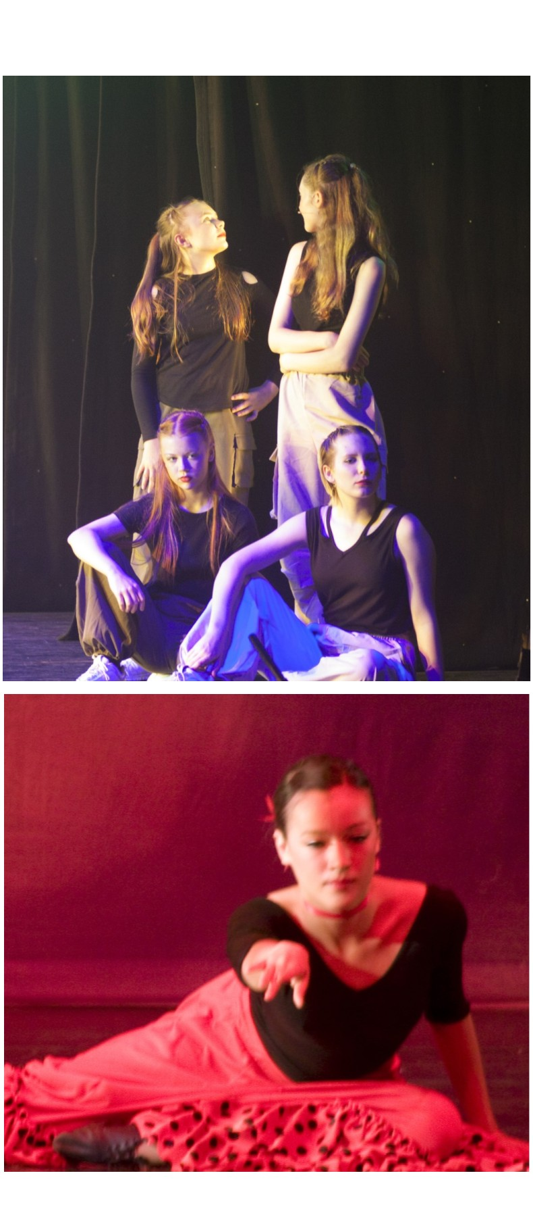
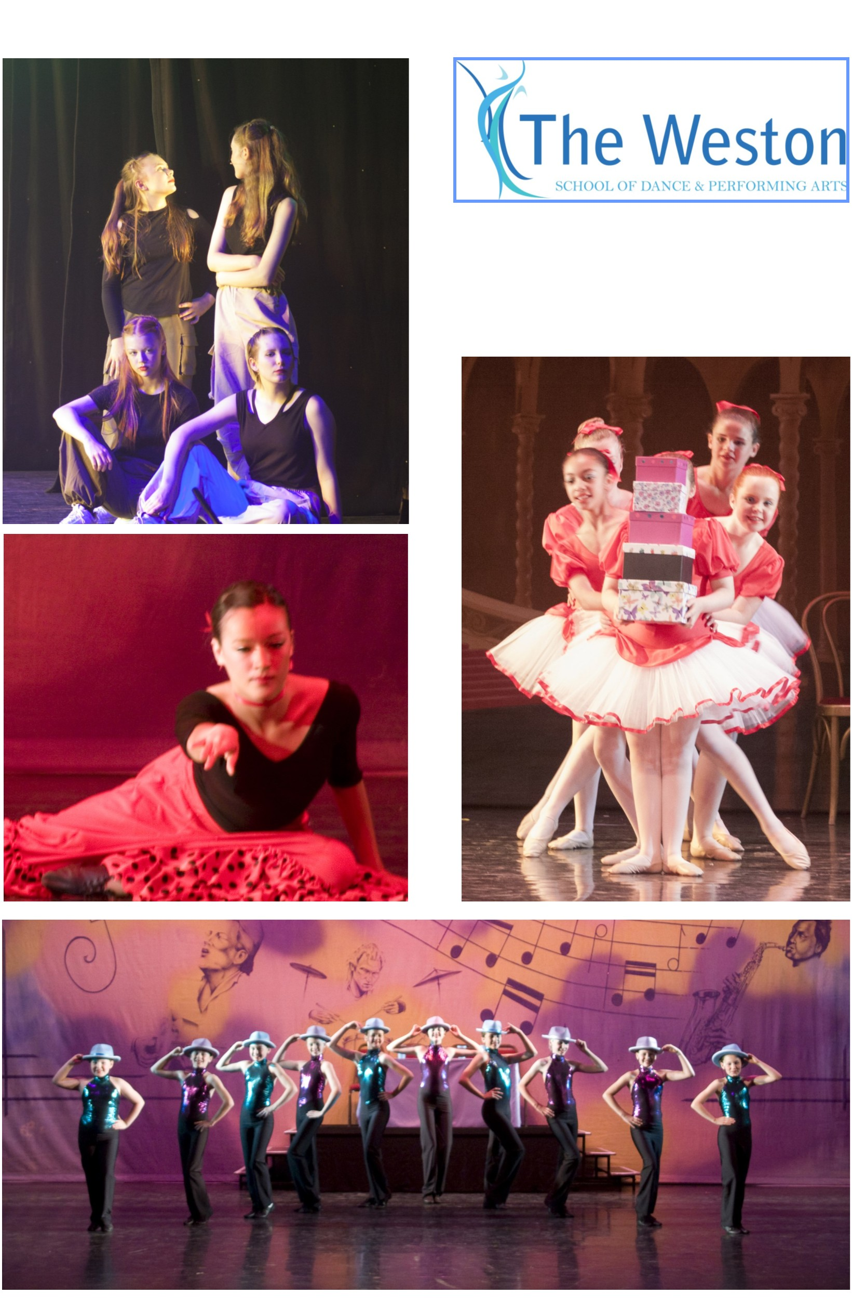
01245 287638
Senior


With over 60 classes per week we list here classes for slightly older children in ballet, modern
theatre and tap dance, together with our musical theatre, contemporary dance and
commercial dance/jazz classes, as planned from September 2026. For the full ꢀmetable please
refer to our website or contact the School Oﬃce - see details on page 4.
Please note that ages are for guidance only and will depend also on experience.
VENUES
CYGAMS HQ, Meteor Way, oﬀ Waterhouse Lane, Chelmsford, CM1 2RL
Farthing Hall, rear of Christchurch, 164 New London Road, Chelmsford, CM2 0AW
Widford Village Hall, Widford Road (oﬀ Chandler’s roundabout), Chelmsford, CM2 8SY
Beaulieu Community Centre, Beaulieu Square, Centenary Way, CM1 6AU
Springﬁeld Parish Centre, St Augusꢀne’s Way, CM1 6GX
Great Dunmow Primary School, Woodlands Park Drive, CM6 1ZR
CLASSICAL BALLET
GRADE 2 (age 9 & 10 years)
Monday AF3/KO 4.45 pm - 5.45 pm Beaulieu Community Centre
Thursday DA2/RF 5.30 pm - 6.30 pm CYGAMS HQ Friday EA1/ES 4.30 pm - 5.30 pm CYGAMS HQ
Friday EH4/KO 6.15 pm - 7.15 pm Springﬁeld Parish Centre
GRADE 3 (age 10 to 12 years)
Monday AA2/ES 4.30 pm - 5.30 pm CYGAMS HQ
Friday EA3/ES 5.30 pm - 6.30 pm CYGAMS HQ
GRADE 4
Friday EA4/ES 6.30 pm - 7.30 pm CYGAMS HQ
STANDARD 5
Wednesday CA2/RF 5.15 pm - 6.15 pm CYGAMS HQ
Saturday FP5/KO 12.15 pm - 1.15 pm Great Dunmow Primary School
STANDARD 6 (**followed by 15 mins pointe work)
Wednesday CA3/RF 6.15 pm - 7.15 pm CYGAMS HQ **
SENIOR CERTIFICATE 1 (**followed by 15 mins pointe work)
Monday AS5/RF 8.00 pm - 9.15 pm Widford Village Hall **
Saturday FJ3/ES 11.45 am - 1.00 pm Great Dunmow Primary School **


MODERN THEATRE DANCE
GRADE 3
Saturday FC3/JL 11.30 am - 12.30 pm Farthing Hall
GRADE 4 (** followed by 30 mins Bronze Jazz Award - opꢀonal)
Saturday FC5/JL 1.45 pm - 2.45 pm Farthing Hall **
GRADE 5 (** followed by 30 mins Silver Jazz Award - opꢀonal)
Monday AS3/RF 5.30 pm - 6.30 pm Widford Village Hall **
GRADE 6
Monday AS4/RF 7.00pm - 8.00 pm Widford Village Hall
TA P DANCE
GRADE 3
Saturday FC4/JL 12.45 pm - 1.45 pm Farthing Hall
GRADE 4
Saturday FC6/JL 2.15 pm - 3.15 pm Farthing Hall
GRADE 6
Friday ES2/RF 4.45 pm - 5.45 pm Widford Village Hall
CONTEMPORARY DANCE
GENERAL (age 11 & over)
Monday AF4/KO 5.45 pm - 6.45 pm Beaulieu Community Centre
MUSICAL THEATRE
JUNIOR (age 7 to 12 years)
Saturday FP4/KO 11.15 am - 12.00 pm Great Dunmow Primary School
SENIOR (age 13 & over)
Saturday FP7/KO 2.15 pm - 3.15 pm Great Dunmow Primary School
COMMERCIAL JAZZ
JUNIOR (age 7 to 10 years)
Saturday FP3/KO 10.30 am - 11.30 am Great Dunmow Primary School
GENERAL (age 8 to 14 years)
Friday EL3/JL 5.00 pm - 6.00 pm Springﬁeld Parish Centre
SENIOR (age 13 & over)
Friday EL4/JL 6.00 pm - 7.00 pm Springﬁeld Parish Centre
Saturday FP6/KO 1.15 pm - 2.15 pm Great Dunmow Primary School

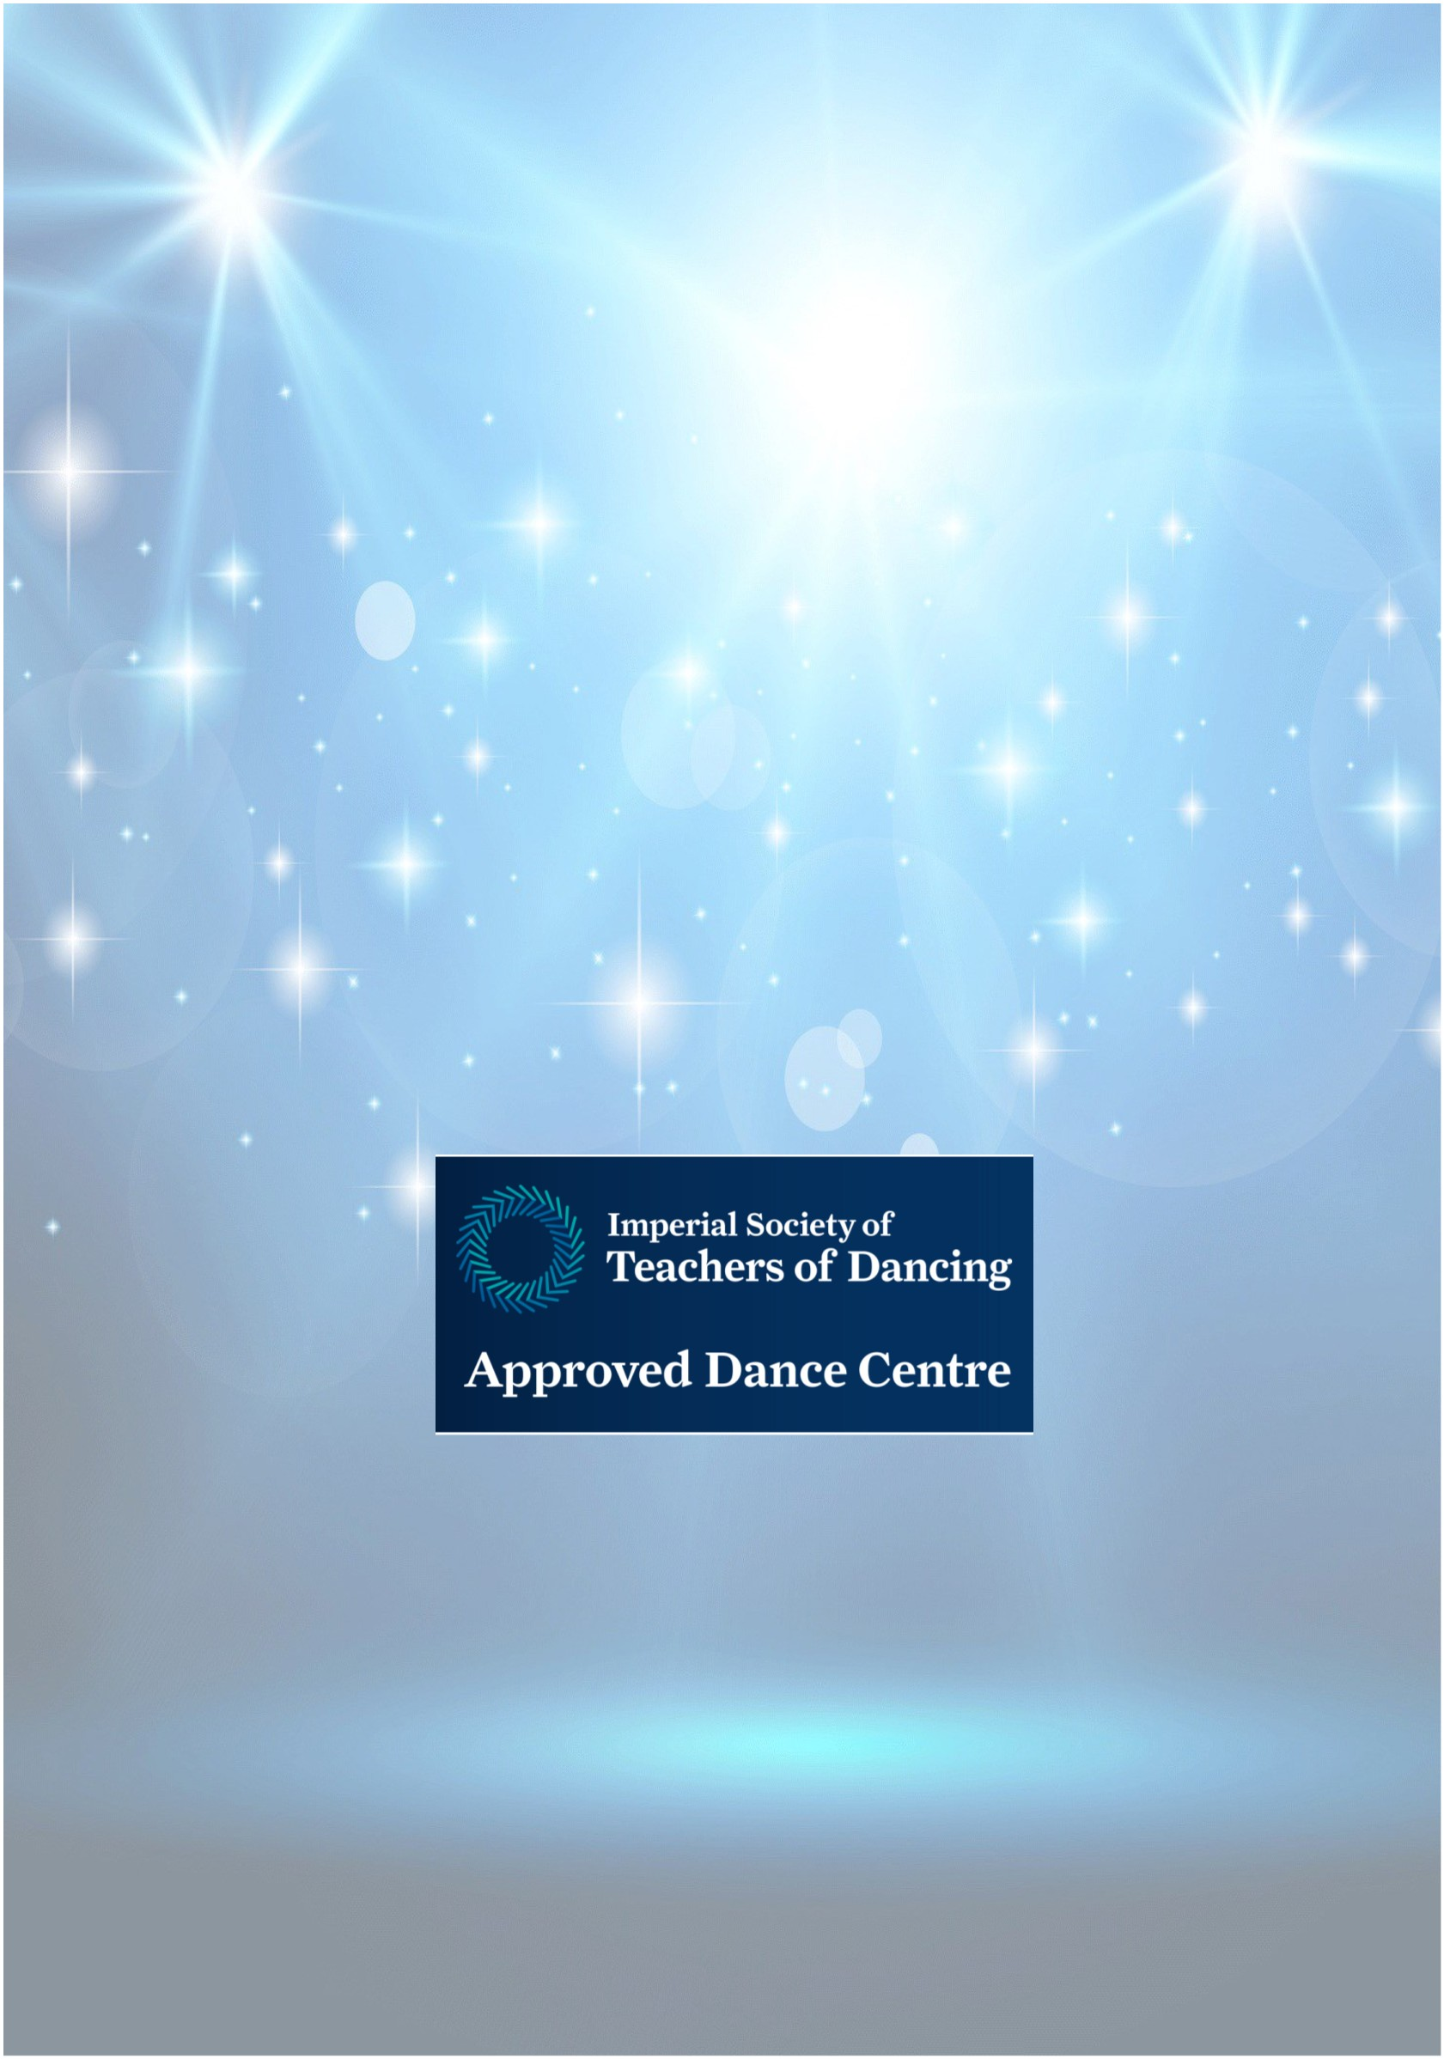
The Weston School of Dance, established in 1939, is recognised as one of the foremost
dance and theatre arts training establishments in Essex. We aim to provide the best
possible training to children, students and adults, in a safe and nurturing environment.
We want everyone to have fun and encourage all our students to achieve as well as they
possibly can, within their own physical and cogniꢀve ability. Examinaꢀons are not
compulsory but are oﬀered, through the ISTD Dance Examinaꢀons Board, to those
training in Ballet, Modern Theatre and Ta p dance.
Our team of experienced teachers, many of whom have performed professionally, are
passionate and enthusiasꢀc about what they do. We hope you will join us soon.
You will ﬁnd a wealth of addiꢀonal informaꢀon on our website:
www.theweston.dance or www.theweston.co.uk
Alternaꢀvely, you are welcome to telephone the School Oﬃce:
01245 287638
(weekdays during term-ꢀme, between 10.00 am and 1.00 pm & 24-hour voicemail)
or email:
oﬃce@theweston.dance or oﬃce@theweston.co.uk
For details of Junior, Vocaꢀonal and Professional Level classes,
plus classes for Adults,
please visit our website or contact the School Oﬃce
WHAT TO DO NOW
Once you have decided on the class or classes for which you wish to enrol
please complete the enrolment form and return this to the School Oﬃce. Your
enrolment will be acknowledged.
Conﬁrmaꢀon will be sent once a place becomes available. You, or your child,
will then be welcome to aꢁend a free trial lesson before making a
commitment.
© Weston School of Dance & Performing Arts 2026 E&OE

