
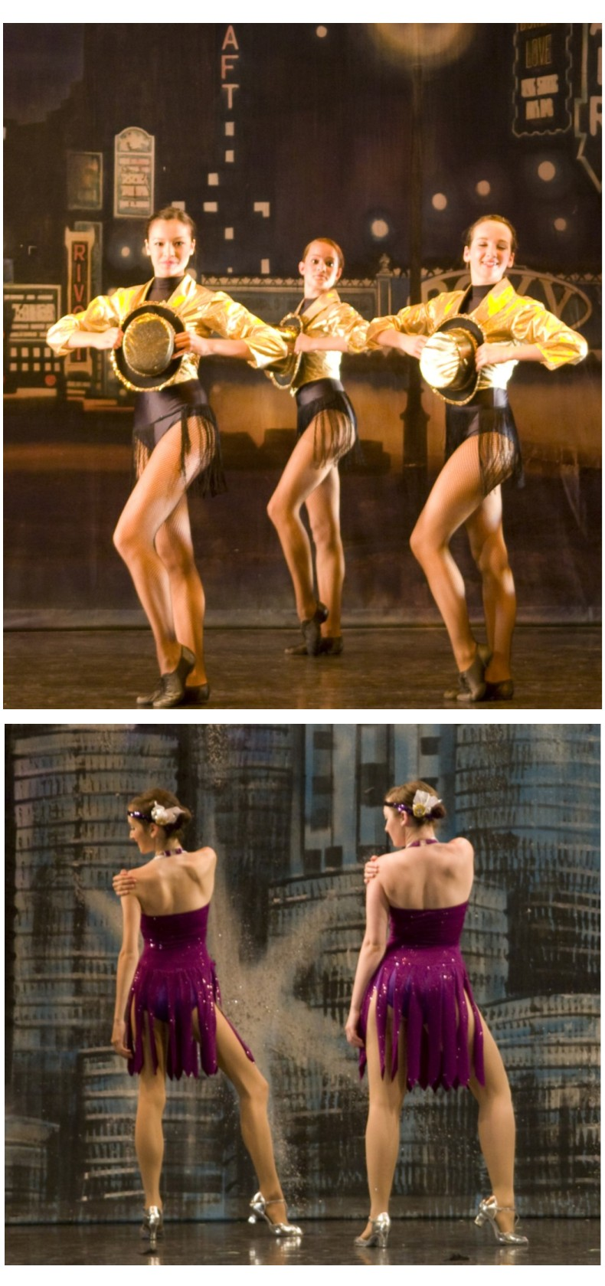
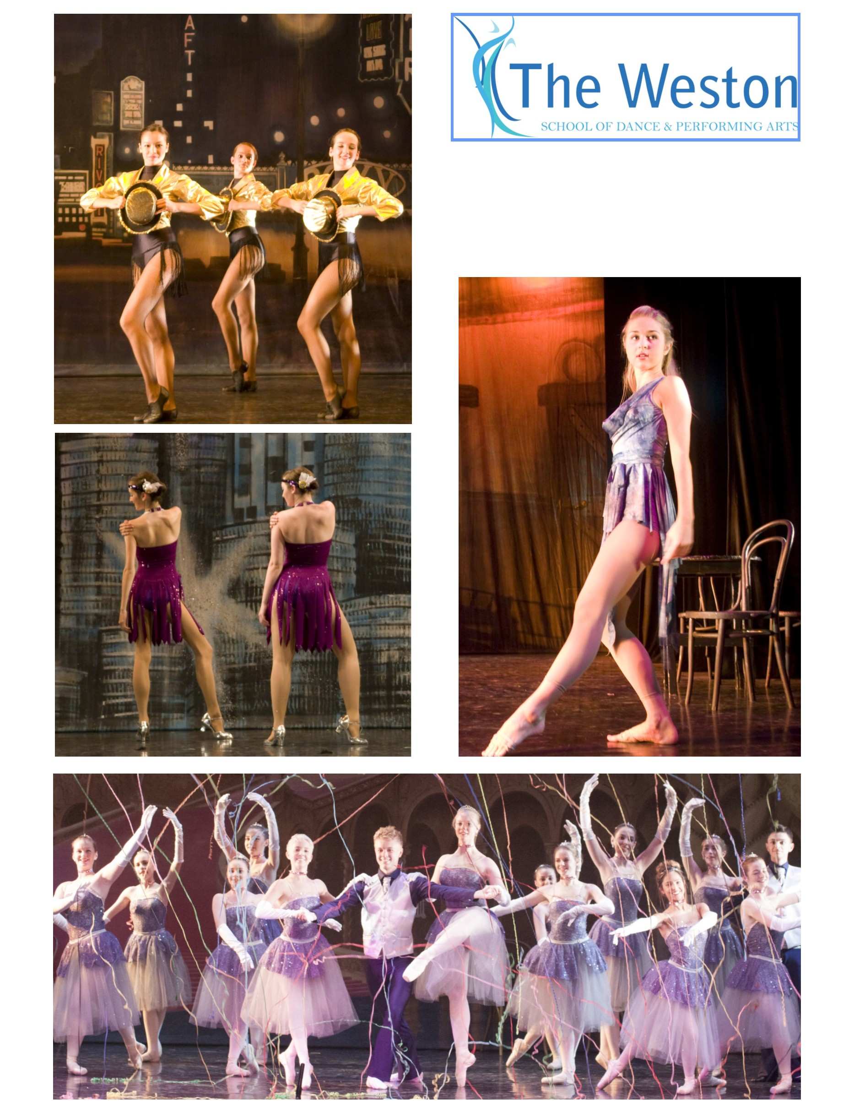
01245 287638
Vocaꢀonal

With over 60 classes per week we list here classes for more advanced students in ballet,
modern theatre and tap dance, together with our musical theatre, contemporary dance and
commercial dance/jazz classes, as planned from September 2025. For the full ꢀmetable please
refer to our website or contact the School Oﬃce - see details on page 4.
Please note that ages are for guidance only and will depend also on experience.
VENUES
CYGAMS HQ, Meteor Way, oﬀ Waterhouse Lane, Chelmsford, CM1 2RL
Farthing Hall, rear of Christchurch, 164 New London Road, Chelmsford, CM2 0AW
Widford Village Hall, Widford Road (oﬀ Chandler’s roundabout), Chelmsford, CM2 8SY
Beaulieu Community Centre (Channels Room), Beaulieu Square, Centenary Way, CM1 6AU
Springﬁeld Parish Centre, St Augusꢀne’s Way, CM1 6GX
Great Dunmow Primary School, Woodlands Park Drive, CM6 1ZR
CLASSICAL BALLET
INTERMEDIATE
Monday AA3/ES 5.30 pm - 7.00 pm CYGAMS HQ, Waterhouse Lane
INTERMEDIATE + POINTE WORK
Monday AA3P/ES 5.30 pm - 7.30 pm CYGAMS HQ, Waterhouse Lane
ADVANCED 1 (Female)
Monday AA4/ES 7.30 pm - 9.00 pm CYGAMS HQ, Waterhouse Lane
ADVANCED 1 (Female) + POINTE WORK
Monday AA4P/ES 7.30 pm - 9.30 pm CYGAMS HQ, Waterhouse Lane
ADVANCED 1 (Male)
Saturday FJ2/ES 10.15 am - 11.45 am Great Dunmow Primary School
VOCATIONAL LEVEL— (NON-SYLLABUS)
Tuesday BA2/ES 5.00 pm - 6.30 pm CYGAMS HQ, Waterhouse Lane
VOCATIONAL LEVEL— (NON-SYLLABUS ) + POINTE WORK
Tuesday BA2P/ES 5.00 pm - 7.00 pm CYGAMS HQ, Waterhouse Lane
DDE UNIT 4
By arrangement

MODERN THEATRE DANCE
INTERMEDIATE
Thursday DA1/RBD 4.00 pm - 5.30 pm CYGAMS HQ, Waterhouse Lane
ADVANCED 1
Friday ES4/RBD 7.00 pm - 8.15 pm Widford Village Hall, Widford Road
DDE UNIT 4
By arrangement
TA P DANCE
INTERMEDIATE
Friday ES3/RF 5.45 pm - 7.00 pm Widford Village Hall, Widford Road
ADVANCED 1
Friday ES4/RF 8.15 pm - 9.30 pm Widford Village Hall, Widford Road
ADVANCED 2
Thursday DA3/RF 6.30 pm - 7.30 pm CYGAMS HQ
DDE UNIT 4
By arrangement
MUSICAL THEATRE
SENIOR (age 13 and over)
Saturday FP7/KO 2.15 pm - 3.15 pm Great Dunmow Primary School
COMMERCIAL JAZZ
SENIOR (age 13 and over)
Friday EL4/JL 6.00 pm - 7.00 pm Springﬁeld Parish Centre
Saturday FP6/KO 1.15 pm - 2.15 pm Great Dunmow Primary School
CONTEMPORARY DANCE
GENERAL (age 11 and over)
Monday AF4/KO 5.45 pm - 6.45 pm Beaulieu Community Centre

The Weston School of Dance, established in 1939, is recognised as one of the foremost
dance and theatre arts training establishments in Essex. We aim to provide the best
possible training to children, students and adults, in a safe and nurturing environment.
We want everyone to have fun and encourage all our students to achieve as well as they
possibly can, within their own physical and cogniꢀve ability. Examinaꢀons are not
compulsory but are oﬀered, through the ISTD Dance Examinaꢀons Board, to those
training in Ballet, Modern Theatre and Ta p dance.
Our team of experienced teachers, many of whom have performed professionally, are
passionate and enthusiasꢀc about what they do. We hope you will join us soon.
You will ﬁnd a wealth of addiꢀonal informaꢀon on our website:
www.theweston.dance or www.theweston.co.uk
Alternaꢀvely, you are welcome to telephone the School Oﬃce:
01245 287638
(weekdays during term-ꢀme, between 10.00 am and 1.00 pm & 24-hour voicemail)
or email:
oﬃce@theweston.dance or oﬃce@theweston.co.uk
For details of Non-Vocaꢀonal and Professional Level classes,
plus classes for Children and Adults,
please visit our website or contact the School Oﬃce
WHAT TO DO NOW
Once you have decided on the class or classes for which you wish to enrol
please complete the enrolment form and return this to the School Oﬃce. Your
enrolment will be acknowledged.
Conﬁrmaꢀon will be sent once a place becomes available. You, or your child,
will then be welcome to aꢁend a free trial lesson before making a
commitment.
© Weston School of Dance & Performing Arts 2026 E&OE

